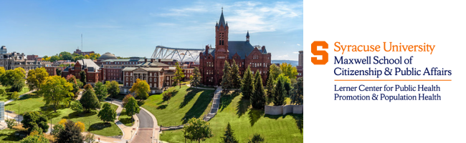
Lerner Center Undergraduate Internship Application Process
The Lerner Center conducts, coordinates, and promotes population and community health research, education, and outreach on the social, spatial, and structural determinants of physical, mental, and behavioral health. The Center is housed within the Maxwell School of Citizenship and Public Affairs. With over 20 faculty affiliates from sociology, psychology, economics, public health, medicine, and public administration, the Lerner Center’s approach to research and education is both multidisciplinary and interdisciplinary.
The Lerner Center also develops and promotes Healthy Monday programs. Healthy Monday is a national public health initiative to end chronic preventable diseases by offering weekly prompts to support people and organizations in starting and sustaining healthy behaviors.
Undergraduate Internship Opportunities:
Undergraduate internship opportunities with the Lerner Center are based on the Center’s need and a student’s experience and interests. The Lerner Center offers three types of internships.
- Health Programming: This intern will work closely with the Assistant Director on Healthy Monday Programming, including program development, implementation, and evaluation.
- Research: This intern will work closely with the Director to aid in on-going research within the Lerner Center. This may include aiding in data collection or analysis, performing literature reviews, developing infographics and education materials, producing issue briefs or data slices for our Research Brief Series, or coordinating research related events on campus. Some research interns will also be invited to participate in Lerner Lab – a venue where Lerner faculty, postdocs, and graduate students convene to get feedback on research ideas and build research and professional skills.
- Health Communications: This intern will aid in developing digital communications for the Lerner Center. This may include digital newsletter development and dissemination, social media content development, tracking analytics and providing recommendations, and fostering and developing social media relationships.
Mentorship: Your internship will include weekly meetings with Lerner Center staff to provide support, guidance, and learning opportunities. We realize a large part of professional development is the opportunity to ask questions, receive feedback, and become more connected to leaders in your field of interest. As an Intern, the Lerner team will help you gain skills and build your network to advance you toward your academic and career goals.
Internship Eligibility:
- Must be enrolled at Syracuse University as a full-time matriculated undergraduate student.
- Must be a sophomore or higher.
- Must be available to work a minimum of 8 hours per week during the Fall, Spring, or Summer semesters.
- Must have an interest in population or public health.
Application Process:
Submit the following materials to Lerner Center Director, Alexandra Punch at aepunch@syr.edu.
- CV or Resume
- One-page cover letter that explains your interest in working with the Lerner Center and how your experiences and/or coursework qualify you for your desired internship placement. Please indicate if this internship request is related to a course or degree requirement.
- Writing sample related to population or public health:
  - For the Health Programming internship, the sample should provide evidence of your ability to develop or advocate for public health programming.
  - For the Research internship, the writing sample should demonstrate your ability to conduct data analysis and/or demonstrate your ability to synthesize peer-reviewed research.
  - For the Health Communications internship, the sample should include representative social media posts or other forms of digital communication.

The Lerner Center will review applications on a rolling basis. Applicants will be notified if their materials and requested semester and hours match with the needs of the Lerner Center.

